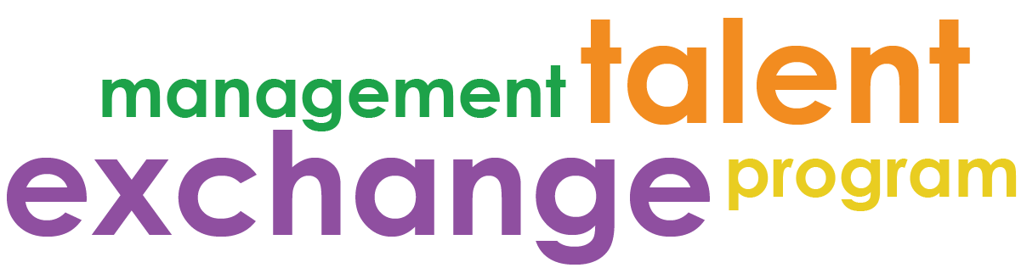

MTEP Participant Toolkit 2019

Contents

Part I: Program Forms – Required
Forms to be submitted to program coordinator by designated due date
- Guidelines – September 12th
- Work Plan Template – September 12th
- Program Reflection – December 6th
- Program Evaluation – December 6th

Part II: Informational – Resources
To get a sense of other MTEP related materials out there
- Project Tracker (for use at your home agency)
- Contact Sheet
- Participant Evaluation
- Buddy Program Overview

