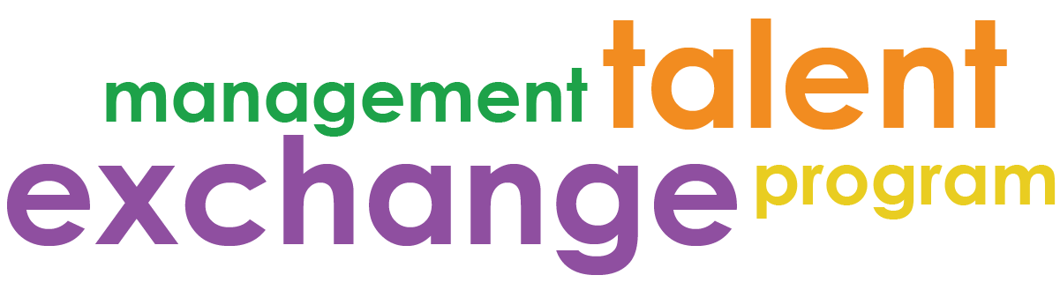

MTEP Host Toolkit 2019

Contents
Part I: Tools for Getting Started – Resources
To support you in hosting your MTEP candidate
- Supervisor Checklist
- Buddy Program Overview
- Onboarding Schedule
- Contact Sheet
- Project Planning Tool
- Getting on the Same Page, Page – Relationship Building
Part II: Program Forms – Required
Forms to be submitted to program coordinator by designated due date
- Guidelines – September 12th
- Participant Work Plan Template – September 12th
- Participant Evaluation – December 6th
- Program Evaluation – December 6th

Part III: Informational – Resources
To get a sense of other MTEP related materials out there
- Host Evaluation
- List of Previous MTEP assignments

