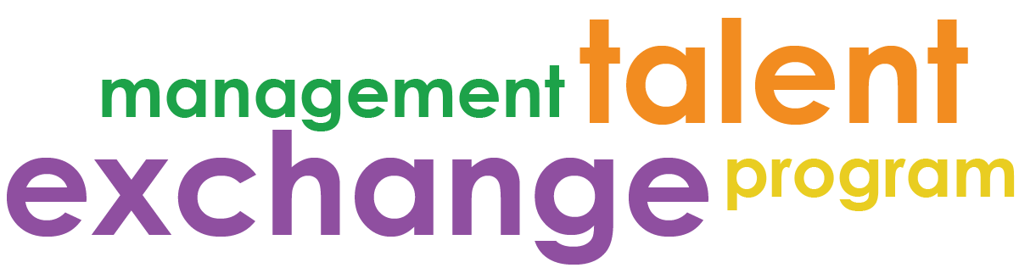

MTEP Relationship Building
Managers are tasked with motivating, developing, and engaging staff in addition to their day to day duties. In MTEP, this is especially tough given the short window in which you have to work with your MTEP participant.
Here are some questions and thoughts to start you off when meeting with your MTEP participant and building your relationship.

Getting to Know Your MTEP Participant
- What are your strengths?
- What are you looking forward to?
- Is there anything you’re nervous or unsure about?
- What is the best way to approach you to talk about how you’re doing in your work? (Scheduled meetings, emails, anytime, etc.)
  - What kind of supervision is most supportive to you?
  - How much guidance/independence do you like?
  - How do you feel when your work is reviewed? Edited? Etc.
  - How do you like your feedback? (methods, frequencies, etc.)
- How would you describe your workstyle?
- How do you prefer to be recognized?
- What questions do you have for me?

Things to consider sharing with your MTEP Participant
- Your communication style, personality type, and preferred work method.
  - Sharing this will help your employees get to know you better and understand you more. Providing this information upfront may also help to prevent communication challenges or misunderstanding later on.
- Your leadership philosophy
  - Who is the leader you’re striving to be? Are you focused on performance, coaching, development, etc.?
- Why you do what you do.
  - What led you to where you are now? Why did you choose your field, the job you’re in, etc.
- How you like feedback
  - How would you prefer staff talk to you when there’s an issue regarding supervision style? Talking about this at the beginning of your relationship will build trust and make it safe for your staff to talk to you about sensitive or vulnerable things that may come up.

